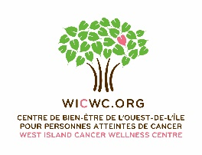
3rd PARTY FUNDRAISER - PROPOSAL FORM
TO BENEFIT THE WEST ISLAND CANCER WELLNESS CENTRE
Please complete and submit to Lisa St-Jacques: lisa@wicwc.org

INFORMATION
Organizer’s Name: ________________________________________
Organization: ________________________________________
Address: ________________________________________
________________________________________
City Province Postal Code

E-mail: _______________________

Telephone#: _______________________

EVENT INFORMATION
Name of Event: __________________________________
Date: ____________________
Time: ____________________
Location: __________________________

Brief description of the event:
____________________________________________________________________________
____________________________________________________________________________
____________________________________________________________________________

EVENT PROMOTION:
Will materials (flyers, posters, etc.) be printed? Yes: No:
Will you require WICWC pamphlets/business cards? Yes: No:
If so, please indicate quantity: _________________
Will you be promoting this event on social media? Yes: No:

FINANCIAL INFORMATION:
Fundraising goal:
$ _________

Is the WICWC the only beneficiary? Yes: No:
If no, please list other beneficiaries:
______________________________ ______________________________

______________________________ ______________________________

WE THANK YOU FOR ALL YOUR SUPPORT!

